**CH 412 LA: INORGANIC CHEMISTRY LABORATORY (Spring 2021)**

**Title:** Synthesis of Tetrakis(triphenylphosphine)palladium(0), Pd(Ph3)4

1. **Purpose: (1 point)**

**To synthesize Tetrakis(triphenylphosphine)palladium(0), Pd(Ph3)4, a compound used in coupling reactions in organic chemistry.**

1. **Drawing of structure of the main compound or balanced chemical equation if synthesis is performed: (1 point)**

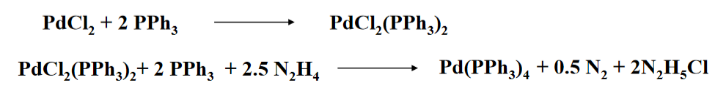

**3. Reagents and the major product (up to 5 points)**

|  |  |  |  |  |  |  |
| --- | --- | --- | --- | --- | --- | --- |
| **Name** | **M.W.**  (0.5 pts) | **Density**  (0.5 pts) | **Amount (grams/mL)**  (0.5 pts) | **Moles**  (0.5 pts) | **Hazards/Precautions**  **(MSDS data) and melting point or boiling point** (2 pts) | **Role of the reagent** (1 pts)* |
| Palladium (II) dichloride | 177.33 | 4 g/cm3 | 0.44 grams | 0.00248 | Harmful if swallowed. Causes serious eye damage. May cause an allergic skin reaction.  MP: 678-680°C | Reactant |
| Hydrazine hydrate | 32.05 | 1.029 g/cm3 | 0.62 grams | 0.0193 | Toxic if swallowed or in contact with skin.  Causes severe skin burns and eye damage.  MP: -52°C  BP: 120°C | Reactant |
| Triphenyl phosphene | 262.29 | 1.07 g/cm3 | 3.28 grams | 0.0125 | Harmful if swallowed. Causes serious eye damage. May cause an allergic skin reaction.  MP: 80°C  BP: 377°C | Reactant |
| Dimethyl sufoxide | 78.13 | 1.100 g/cm3 | 30 mL | 0.422 | Combustible liquid. Can carry dissolved chemicals through skin. May cause eye, skin, and respiratory tract irritation.  MP: 18.4°C  BP: 189°C | Solvent |
| Nitrogen | 28.01 | 0.97 g/cm3 | -- | -- | May displace oxygen and cause suffocation.  MP: -210°C  BP: -196°C | Product |
| Pd(Ph3)4 | 1155.58 | -- | -- | -- | Harmful if swallowed. May form combustible dusts.  MP: 105°C | Product |

**\*** Mention role as either reactant, solvent, catalyst or product

**4. Calculations: (1 point) (ignore it)**

Show each calculation for moles of reagents and for theoretical and actual yield. Fill in the box with the limiting reagent and theoretical yield:

The limiting reagent is

The theoretical yield is

**5. Procedure (up to 2 points)**

|  |  |
| --- | --- |
| **Procedure** | **Observations and Lab Data** |
| A summary of the procedure done with bullet points) | Color changes, exothermic or endothermic reactions, gas generation, etc.; tare weights for flasks, etc. |
| * Dissolve 0.44 g of fine palladium chloride and 3.28 g of triphenylphosphine in 30 mL dimethyl sulfoxide with stirring and heating to 140°C in a closed RBF flushed with argon or nitrogen. * When all of the palladium dichloride is dissolved stop the heating and add slowly 0.62 g hydrazine hydrate over the course of 1 minute. * Cool the solution in a water bath until the mixture becomes turbid and remove it from the ice bath. * Continue the stirring in a room temp for 20 minutes and further cool down 10°C. * Filter and wash with 10 mL ethanol and diethyl ether. Dry in a vacuum. |  |

**6.** Results; include actual yield in grams and % yield.

**Results (need to get signed by instructor or TA):**